# Recipes

You need to add 17 things to this document. (Make sure to number them just as I did in the example.) It may be helpful to copy and paste this list and then fill it in as you go along. All image names must start with your location, e.g yellowstone_sunset.jpg unless you are using a link from the internet.

## Name of recipe

1. **Origin**: Italian, Korean, Mexican, American, etc, write unknown if unknown
2. **Source**: (Prefer own recipe, but you can add a link here.)
3. **Category**: Main Dish, Vegetarian, Comfort Food, Dessert, etc.
4. Primary Image of food
5. Name of file with food picture (make sure to add the picture to the proper Google Drive!)
6. Paragraph One about the recipe
7. **Recipe Ingredients – Just write Recipe Ingredients**
   1. Ingredient
   2. Ingredient
   3. Ingredient
   4. etc.
8. **Recipe Steps – Just write Recipe Steps**
   1. Step
   2. Step
   3. Step
   4. Step
9. **Additional Food images**

For the next three pictures you can just put the names of the files, you don't have to include the files in this drive, but you do need to add them to the proper Google Drive.

1. file name
2. Visual description of the image/movie
3. file name
4. Visual description of the image/movie
5. file name
6. Visual description of the image/movie
7. Your Name(s)

## Chicken Curry

1. **Origin**: Japan
2. **Source**: Family Recipe
3. **Category**: Main Dish
4. 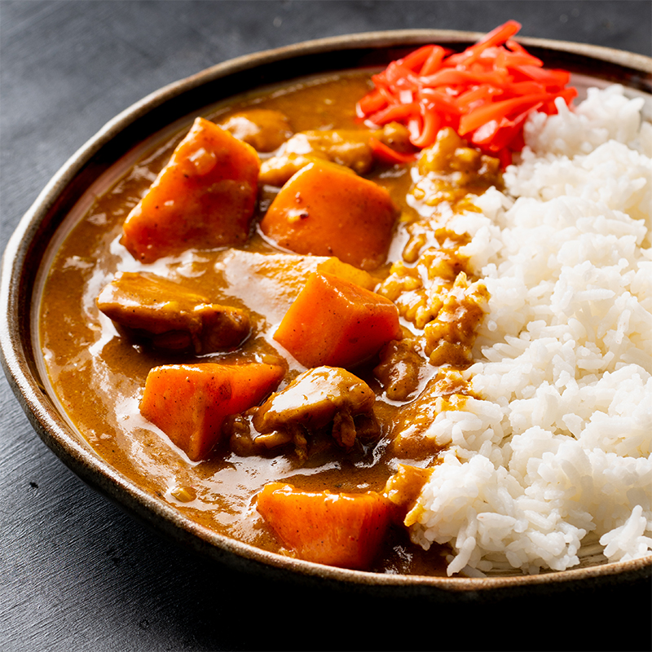
5. Japanese Chicken Curry.jpg
6. Unlike Indian or Thai curry, Japanese curry is more savory than spicy. It’s an exemplary comfort food and one of the most-loved home-cooked dishes in Japan.
7. **Recipe Ingredients** 
   1. skinless, boneless chicken breast
   2. 1 tablespoon olive oil
   3. 1 pinch salt and ground black pepper
   4. water
   5. 1 package curry sauce mix
   6. 1 can peas
   7. 5 new potatoes, halved
   8. 1 package sliced cremini mushrooms
   9. 2 medium carrots, chopped
   10. 1 medium onion, chopped
   11. 2 cups jasmine rice
8. **Recipe Steps** 
   1. Place chicken in a large, deep skillet. Drizzle with olive oil and season with salt and pepper on both sides. Add 1/3 cup water to the pan, cover, and cook over medium heat until no longer pink in the center and the juices run clear, about 20 minutes.
   2. While chicken is cooking, pour 2 cups water into a microwave-safe bowl. Break curry sauce mix into pieces and add to water. Heat in the microwave on high for 3 1/2 minutes; remove and stir until sauce mix has completely dissolved.
   3. Remove chicken from the skillet. Cut into cubes, return to the skillet, and pour curry sauce over top. Stir in peas, potatoes, mushrooms, carrots, and onion. Bring to a boil, then lower heat and simmer until vegetables are tender, about 30 minutes.
   4. Meanwhile, bring remaining water and rice to a boil in a saucepan. Reduce heat to medium-low, cover, and simmer until rice is tender and water has been absorbed, 20 to 25 minutes.
   5. Scoop rice into bowls and serve curry on top.
9. **Additional Food images**
10. curry sauce.jpeg
11. Curry sauce
12. raw chicken breast.jpeg
13. Raw chicken breast
14. rice.jpeg
15. Rice
16. Zhehong Wu